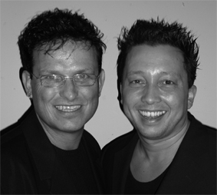
El Mismo Tren

Choreografers : Roy Verdonk and Wil Bos
Level : Easy Intermediate

Dance : 4 wall

Counts : 64 counts
Music : En El Mismo tren – Marco Antonio Solis ( CD - Razón De Sobra )
Intro : 64 counts – start on vocals

Rhumba Box, Hold, Step, ½ Turn, ¼ Turn Step, Hold
1-2-3-4 Step right to right side, Close left next to right, Step right forward, Hold
5-6 Step left forward, ½ Turn right
7-8 ¼ Turn right step left to left side, Hold

Cross, Step, Cross Rock, Recover, Side Step, Cross, ¼ Turn Side Step, Hold
1-2 Cross right behind left, Step left to left side
3-4 Cross right over left, Recover
  - Step right to right side, Cross left over right
7-8 ¼ turn left step right back, Hold

Coaster Step, Hold, Step, ¼ Turn, Cross, Hold
1-2-3-4 Step left back, Close right next to left, Step left forward, Hold
      - Step right forward, ¼ turn left, Cross right over left, Hold

Side, Cross, Side, Cross Sweep, Cross, Side, Cross, Hold
  - Step left to left side, Cross right over left
  - Step left to left side, Cross right over left and sweep left from back to front
  - Cross left over right, Step right to right side
  - Cross left over right, Hold

Side, Close, ¼ Turn, Hold, Jazz Box ¼ turn left
      - Step right to right side, Close left next to right, ¼ turn right step right forward, Hold
      - Cross left over right, ¼ turn left step right back, Step left to left side, Hold

Mambo ½ Turn right, Hold, Step, Pivot, Step, Hold
      - Rock right forward, Recover, ½ Turn right step right forward, Hold
5-6-7-8 Step left forward, ½ turn right, Step left forward, Hold

Side, Close, Cross, Hold, ¼ Turn, ¼ Turn, Step, Hold
      - Step right to right side, Close left next to right, Cross right over left, Hold
      - ¼ turn right step left back, ¼ turn right step right to right side, Step left forward, Hold

Step, Pivot, Step, Hold (x2)
      - Step right forward, ½ turn left, Step right forward, Hold
      - Step left forward, ½ turn right, Step left forward, Hold

Start again and let the music touch your soul

